
DEPARTMENT OF INFORMATION TECHNOLOGY

24ITT32 - PROGRAMMING IN JAVA

INDIVIDUAL PROJECT ON
ACADEMIC MANAGEMENT SYSTEM

P R O J E C T R E P O R T
Submitted by
SARAVANAN S.N
25ITR130
JAVA ASSIGNMENT

AIM:
Development of Kongu Engineering College (R2024) Student Academic & Continuous Evaluation System using Java JDBC.

OBJECTIVE:
Design and develop a database-driven Java application using JDBC to manage student records, perform incremental marks entry (Continuous Internal Assessments and End Semester Examinations), enforce attendance eligibility rules, and generate formal academic performance reports according to
Kongu Engineering College (Autonomous) - Regulation 2024.
System Requirements & Specifications.

FLOW CHART:
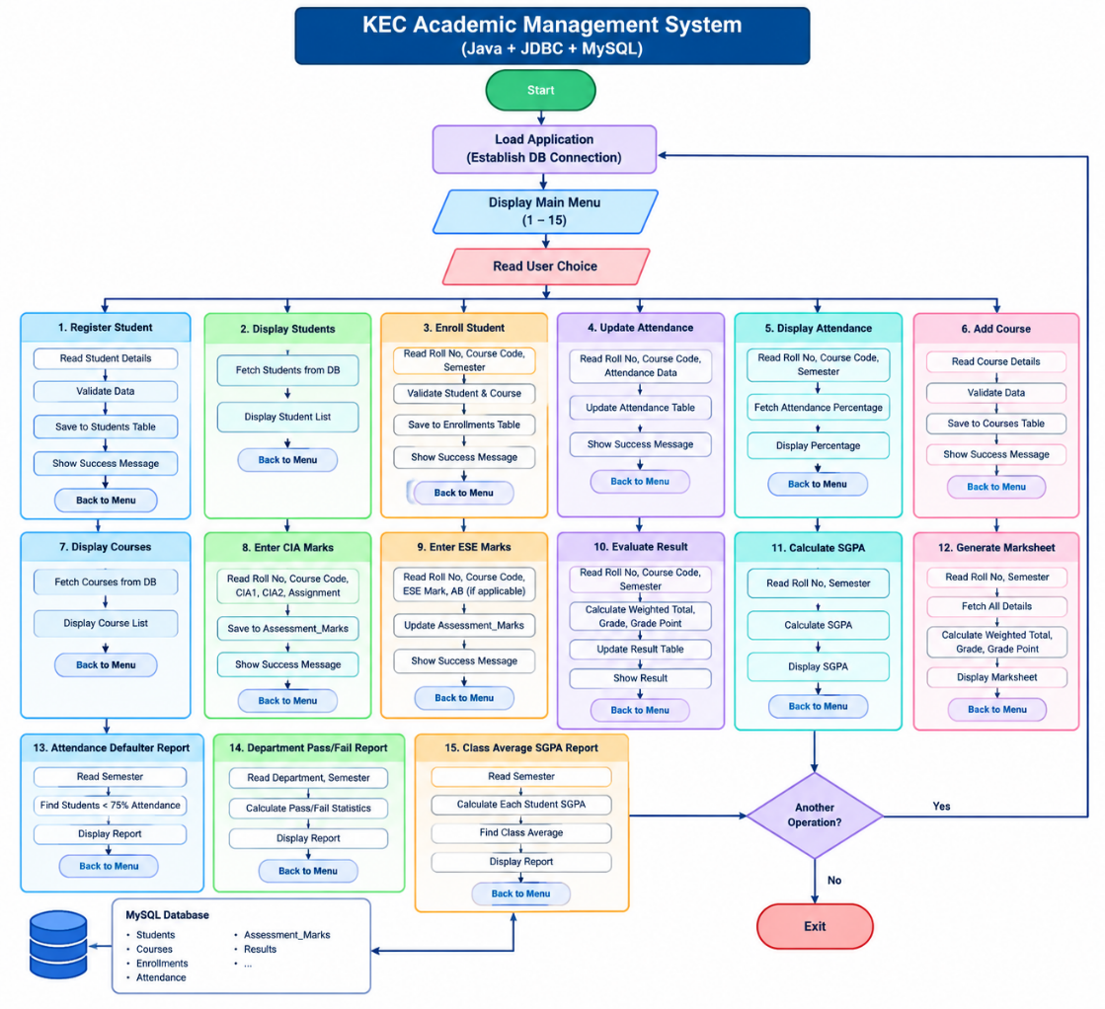
PROCEDURE:
- Install and configure Java JDK, VS Code, MySQL Server, and MySQL Connector/J.
- Create a Java project named KEC-Academic-System and add the MySQL Connector/J library.
- Create the database kec_academics in MySQL and define the required tables for students, courses, enrollments, and assessment marks.
- Create DBConnection.java to establish a connection between Java and MySQL using JDBC.
- Create StudentDAO.java to register and display student details.
- Create AcademicDAO.java to manage courses, enrollment, attendance, marks, grades, and academic reports.
- Create MainApp.java to display the menu and call the appropriate methods based on the user's choice.
- Execute the SQL script and verify the database connection.
- Run MainApp.java and test student registration, course enrollment, attendance updates, and marks entry.
- Verify the stored records and academic results to ensure the system functions correctly.
DATABASE SCHEMA:
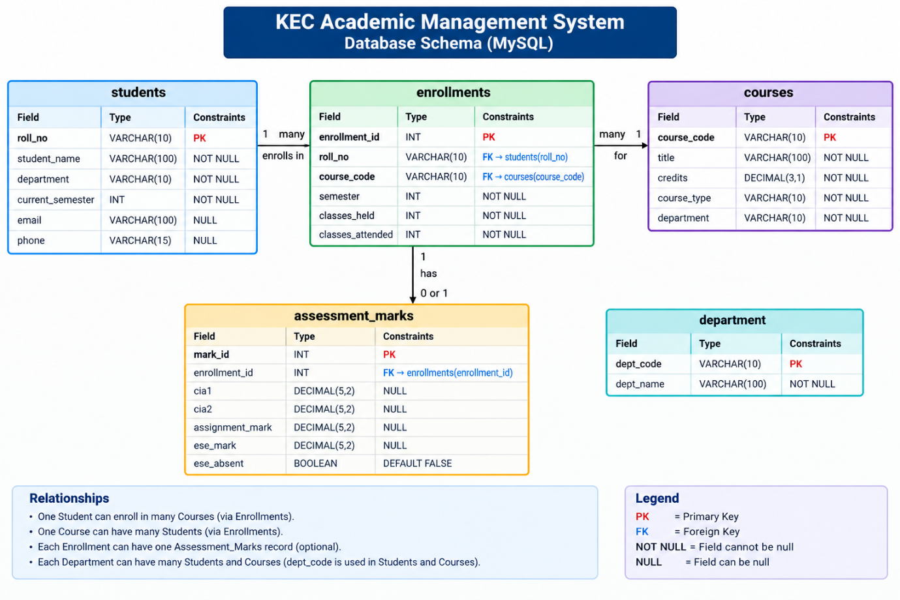

SOURCE CODE:
1. DBConnection.java
import java.sql.Connection;
import java.sql.DriverManager;
import java.sql.SQLException;

public class DBConnection {

private static final String URL =
"jdbc:mysql://localhost:3306/kec_academics";

private static final String USER = "root";
private static final String PASSWORD = "YOUR_MYSQL_PASSWORD";

public static Connection getConnection() throws SQLException {
return DriverManager.getConnection(URL, USER, PASSWORD);
}
}
2. StudentDAO.java

import java.sql.Connection;
import java.sql.PreparedStatement;
import java.sql.ResultSet;
import java.sql.SQLException;

public class StudentDAO {

public void addStudent(String rollNo, String name,
String department, int semester) {

String sql = "INSERT INTO students "
+ "(roll_no, student_name, department, current_semester) "
+ "VALUES (?, ?, ?, ?)";

try (Connection con = DBConnection.getConnection();
PreparedStatement ps = con.prepareStatement(sql)) {

ps.setString(1, rollNo);
ps.setString(2, name);
ps.setString(3, department);
ps.setInt(4, semester);

ps.executeUpdate();
System.out.println("Student registered successfully.");

} catch (SQLException e) {
System.out.println("Registration error: " + e.getMessage());
}
}

public void displayStudents() {

String sql = "SELECT roll_no, student_name, department, "
+ "current_semester FROM students ORDER BY roll_no";

try (Connection con = DBConnection.getConnection();
PreparedStatement ps = con.prepareStatement(sql);
ResultSet rs = ps.executeQuery()) {

System.out.println("\n===== STUDENT LIST =====");

while (rs.next()) {
System.out.println(
rs.getString("roll_no") + " | "
+ rs.getString("student_name") + " | "
+ rs.getString("department") + " | Semester "
+ rs.getInt("current_semester"));
}

} catch (SQLException e) {
System.out.println("Display error: " + e.getMessage());
}
}
}

3.MainApp.java

import java.util.Scanner;

public class MainApp {
public static void main(String[] args) {
Scanner sc = new Scanner(System.in);
StudentDAO students = new StudentDAO();
AcademicDAO academic = new AcademicDAO();

while (true) {
System.out.println("\n=== KEC ACADEMIC MANAGEMENT SYSTEM ===");
System.out.println("1. Register Student");
System.out.println("2. Display Students");
System.out.println("3. Enroll Student");
System.out.println("4. Update Attendance");
System.out.println("5. Display Attendance");
System.out.println("6. Add Course");
System.out.println("7. Display Courses");
System.out.println("8. Enter CIA Marks");
System.out.println("9. Enter ESE Marks");
System.out.println("10. Evaluate Results");
System.out.println("11. Calculate SGPA");
System.out.println("12. Generate Marksheet");
System.out.println("13. Attendance Defaulters");
System.out.println("14. Department Pass/Fail Report");
System.out.println("15. Class Average SGPA");
System.out.println("0. Exit");
System.out.print("Enter choice: ");

try {
int choice = Integer.parseInt(sc.nextLine());

switch (choice) {
case 1:
students.addStudent();
break;
case 2:
students.displayStudents();
break;
case 3:
academic.enrollStudent();
break;
case 4:
academic.updateAttendance();
break;
case 5:
academic.displayAttendance();
break;
case 6:
academic.addCourse();
break;
case 7:
academic.displayCourses();
break;
case 8:
academic.enterMarks(true);
break;
case 9:
academic.enterMarks(false);
break;
case 10:
academic.evaluateStudent();
break;
case 11:
academic.calculateSGPA();
break;
case 12:
academic.generateMarksheet();
break;
case 13:
academic.attendanceDefaulterReport();
break;
case 14:
academic.departmentPassFailReport();
break;
case 15:
academic.classAverageSGPAReport();
break;
case 0:
System.out.println("Exiting system...");
sc.close();
return;
default:
System.out.println("Invalid choice!");
}
} catch (Exception e) {
System.out.println("Error: " + e.getMessage());
}
}
}
}
OUTPUT SCREENSHOTS:

MAIN MENU:
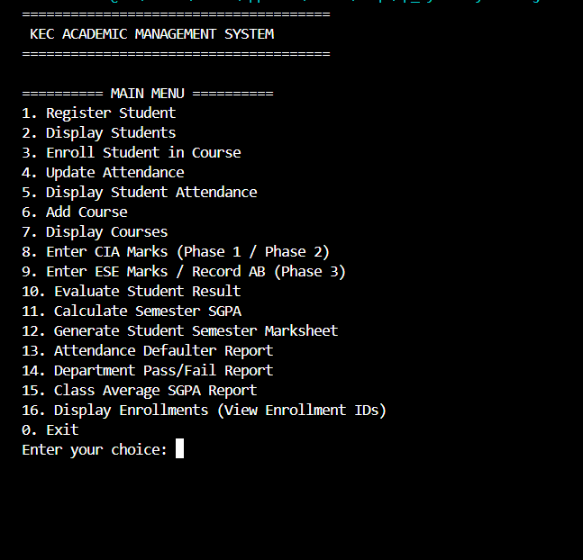
OUTPUT
1.STUDENT REGISTRATION:
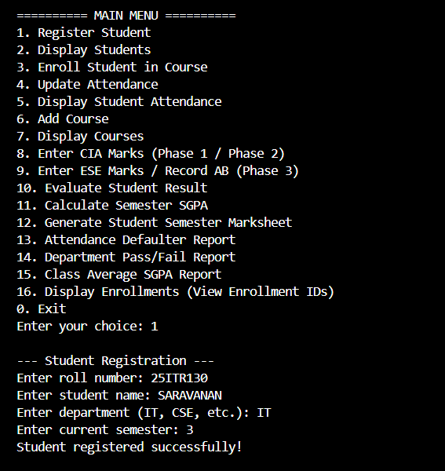
2. COURSE CATALOG:
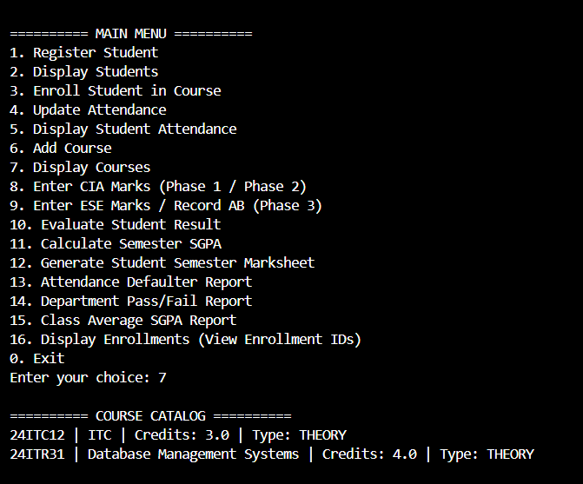
3. COURSE ENROLLMENT:
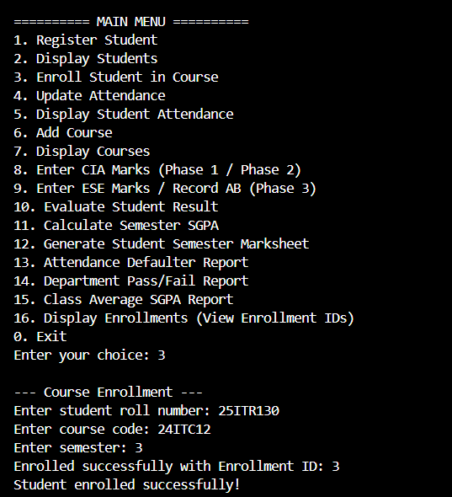
3. COURSE REGISTRATION:
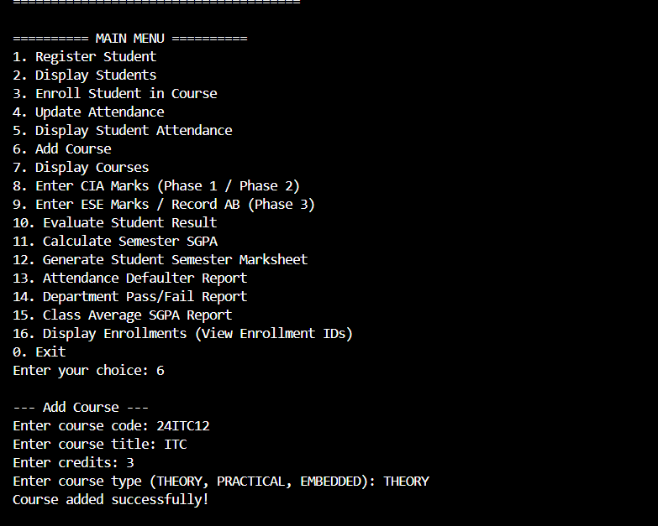
MARKS ENTRY:
1.PHASE 1 (CIA-MARKS):
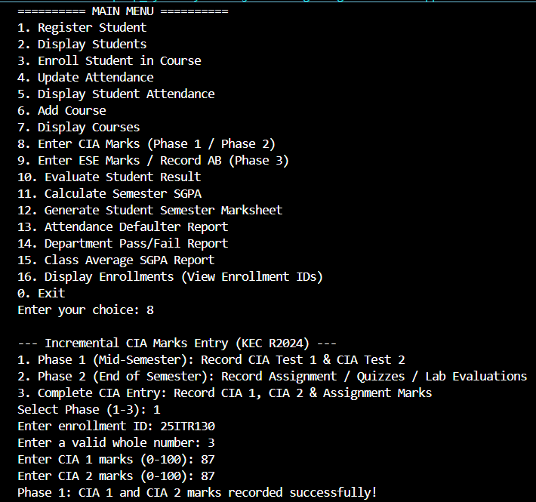
2.PHASE 2 (ASSIGNMENT MARKS):
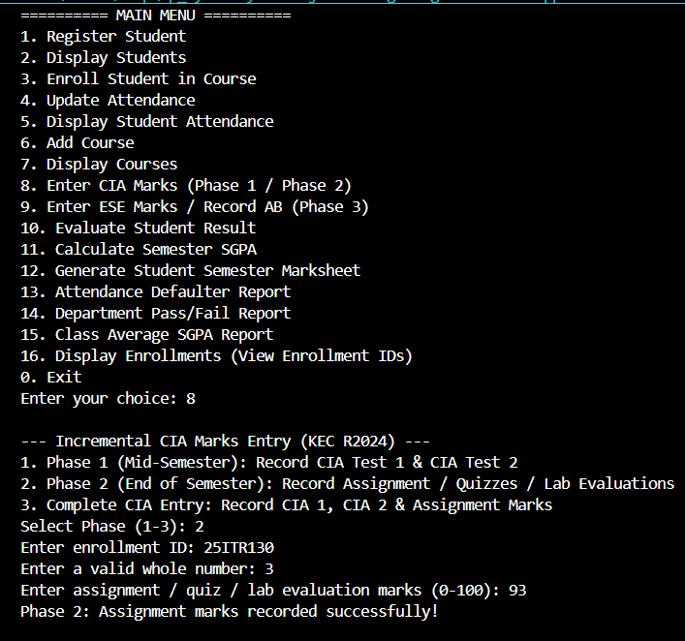
3. PHASE 3 ( SEMESTER):
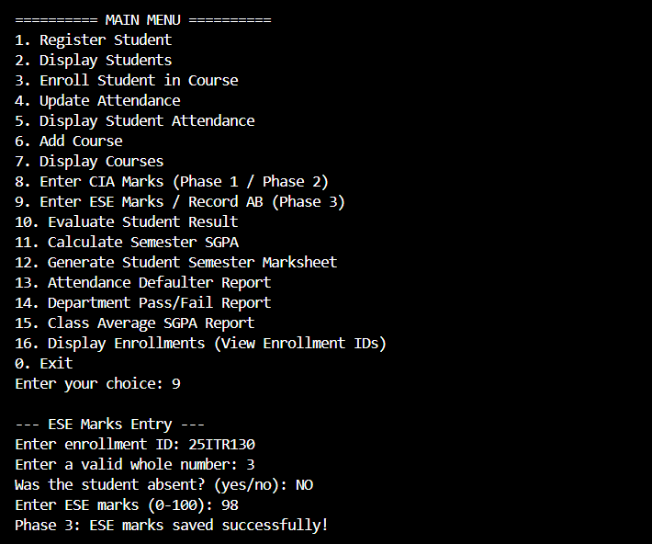

ATTENDANCE & GRADING RULES:
1.ATTENDANCE UPDATE:
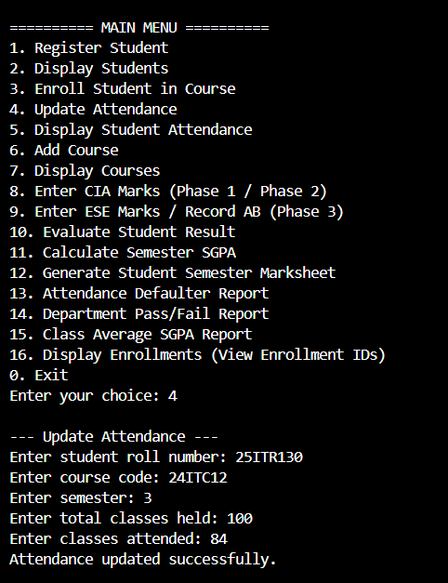
2.DISPLAY ATTENDANCE:
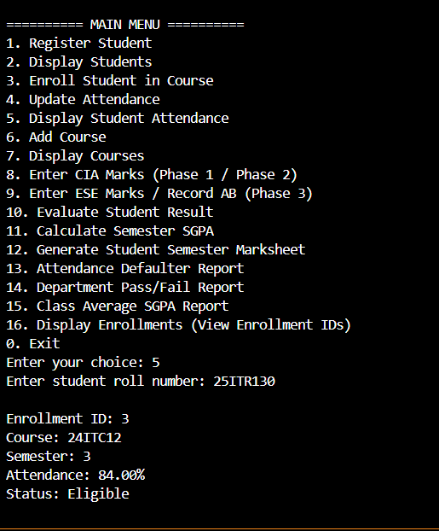
STUDENT RESULT:
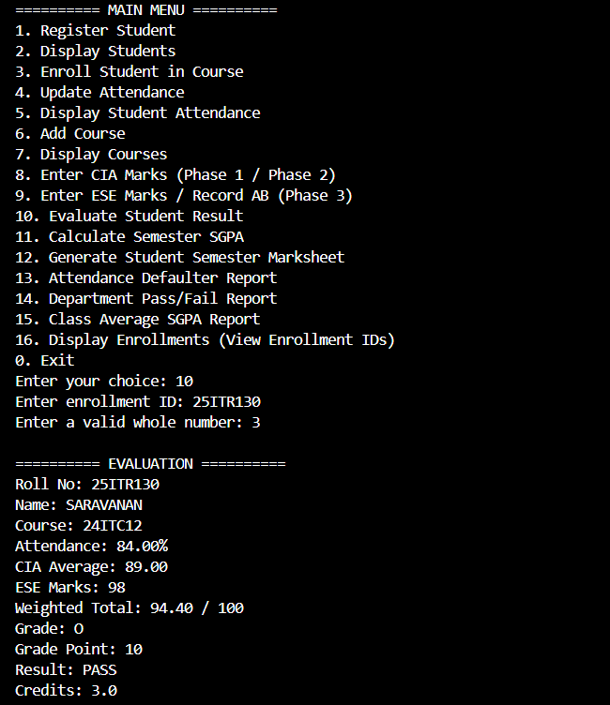
STUDENT CGPA:
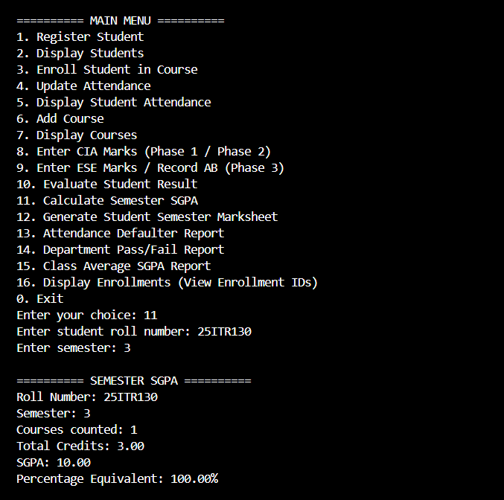

STUDENT MARKSHEET:
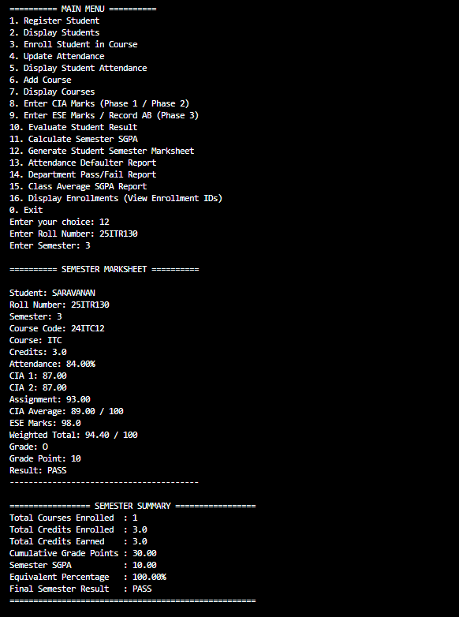

DEPARTMENT WISE CLASS PERFORMANCE & RESULT SUMMARY:
1.ATTENDANCE REPORT:
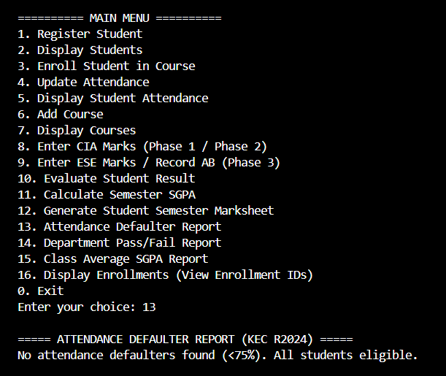
2.DEPARTMENT PASS/FAIL REPORT:
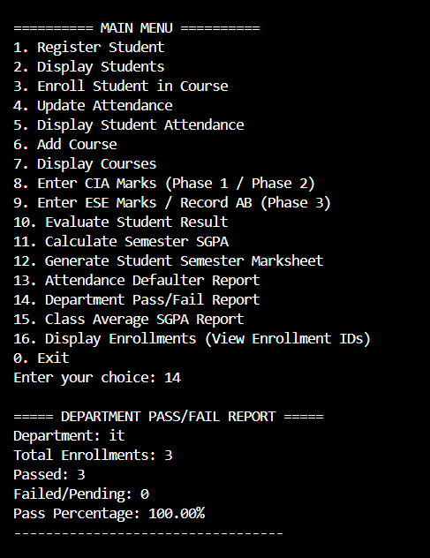
3.DEPARTMENT CGPA REPORT:

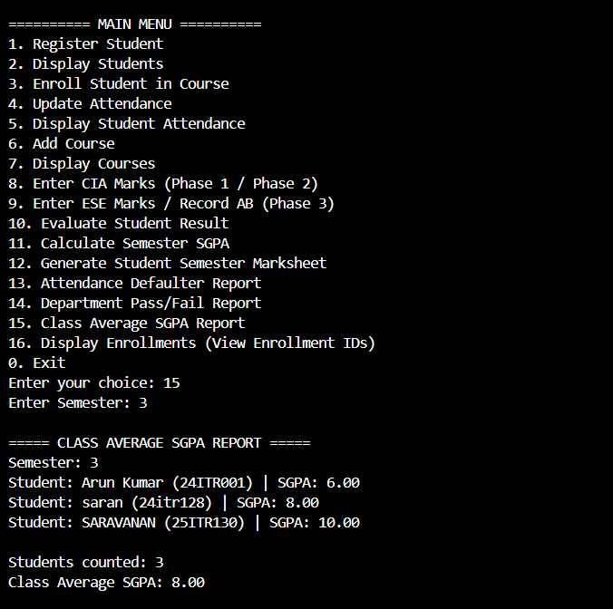

RESULT:
Thus, the Student Academic and Continuous Evaluation System for Kongu Engineering College (Autonomous) Regulation 2024 was successfully designed, developed, and tested using Java (JDBC) and MySQL. The system accurately automates the calculation of Continuous Internal Assessments (CIA), End Semester Examinations (ESE), Letter Grades, Attendance Eligibility, and Semester Grade Point Average (SGPA).
REFERENCES:
1. Oracle, Java SE Documentation – JDBC Overview and Architecture. https://docs.oracle.com/javase/8/docs/technotes/guides/jdbc/ .
2. Oracle, Java SE API Specification – java.sql Package. https://docs.oracle.com/en/java/javase/17/docs/api/java.sql/package-summary.html .
3. Oracle, Java SE API – PreparedStatement. https://docs.oracle.com/en/java/javase/17/docs/api/java.sql/java/sql/PreparedStatement.html .
4. Oracle, Java SE API – HttpServer. https://docs.oracle.com/en/java/javase/17/docs/api/jdk.httpserver/com/sun/net/httpserver/HttpServer.html .
5. Oracle, MySQL 8.0 Reference Manual. ht+-tps://dev.mysql.com/doc/refman/8.0/en/ .
6. Oracle, MySQL Connector/J Developer Guide. https://dev.mysql.com/doc/connector-j/8.0/en/ .
7. Oracle, Java Tutorials – JDBC Basics. https://docs.oracle.com/javase/tutorial/jdbc/basics/ .
8. University Grants Commission, Guidelines for Choice Based Credit System (CBCS). https://www.ugc.gov.in/pdfnews/8023719_Guidelines-for-CBCS.pdf .
9. Chart.js, Chart.js Documentation. https://www.chartjs.org/docs/latest/ .
10. Tailwind CSS, Tailwind CSS Documentation. https://tailwindcss.com/docs .

GITHUB:
LINK: | https://github.com/saravanansn42622007-boop/JAVA-PROJECT1.git

